Vegetation Community Monitoring Protocol for the Heartland Inventory and Monitoring Network

Standard Operating Procedure 8: Processing unknown specimens

Version 1.00 (2018)

Revision History Log:

| Previous Version # | Revision Date | Author | Changes Made | Reason for Change | New Version # |
| --- | --- | --- | --- | --- | --- |
|  | 2018 | S.A. Leis | Separate from the ground flora SOP formerly included in SOP 5. | Provide clarity and increase usability | 1.0 |
|  |  |  |  |  |  |
|  |  |  |  |  |  |
|  |  |  |  |  |  |

This SOP was formerly included with the herbaceous data collection SOP. We have separated it to increase utility and clarity. This SOP provides guidance for the process of collecting and/or recording unknown specimens encountered during plant community monitoring. Unknown specimens can be encountered while collecting ground flora data, tree regeneration data, or overstory tree data. Every effort should be made to accurately identify plants to the most specific taxonomic level possible. Exceptions are noted in SOP 7-Measuring the Ground Flora. Current federally threatened and endangered species are known for each park. Botanists should be able to recognize these species prior to sampling. They should not be collected.

Resources

Equipment

See previous SOPs for equipment list.

Additional items for processing unknown specimens:

* Data sheets: Unknown plant specimen Figure 8.0
* Field guides and identification aides
* Plant press (loaded with blotters and fresh newspaper)
* Plant species list for site
* Tree list
* Sharpie type markers
* Unknown specimen book
* Ziplock bags for collecting specimens
* Hand lens

Processing Unknown Specimens

Plants not immediately identified in the plot are recorded on the data sheet with an unknown specimen code (<park code> <unknown number> <date>, e.g., WICRunk2_072003). If at least 10 – 15 individuals of the unknown species are present at a site, a specimen maybe collected from outside the plot. A sample demonstrating key features of that species may then be collected. Because of the long-term nature of the monitoring, collecting outside the plot is preferred. If a specimen does not occur outside the plot, a portion of the plant from inside the plot can be collected, but at no time should the roots be dug up or the entire plant be collected from inside the plot. Collecting the roots and/or the entire above-ground portion of the plant may affect future sampling events.

For each unknown specimen, there is a corresponding Unknown Specimen datasheet, provided below. The more detailed a definition of each characteristic, the greater the possibility of a future identification. Use the following procedure when filling out the Unknown Record sheet:

Place the specimen in a plant press. Include the completed unknown datasheet with the specimen. Also label the newsprint the specimen is within using sharpie. Include the unknown number and collector’s initials. Create an entry in the unknown log. This log can be updated with the positive identification prior to data entry. The logbook serves as a permanent record of the unknown plant. Lastly, enter the unknown code on the Ground Flora datasheet.

Photos of unknown plants are valuable whether collecting the specimen or not. The photo location and plant characteristics along with the image number should be recorded to aide in later identification. Be sure to take additional pictures of diagnostic features. If collecting is not possible because of rarity, poisonous status, size/shape, pictures may be taken in lieu of a physical specimen. Be sure to use the HTLN camera and record the image number in a logbook which corresponds to the unknown datasheet. Avoid using personal or individual cell phone camera. Maintain all the specimen images on the same device.

After field work is complete and botanists can spend time identifying unknown specimens, be sure to consult a variety of botanical resources, including experts. Keep the specimens until data entry is complete. Once data entry is complete the project leader may decide whether to keep the specimens. High quality specimens can be mounted and stored in the herbarium. If mounting the specimen, use the HTLN/NPS label and create an entry in the herbarium database.

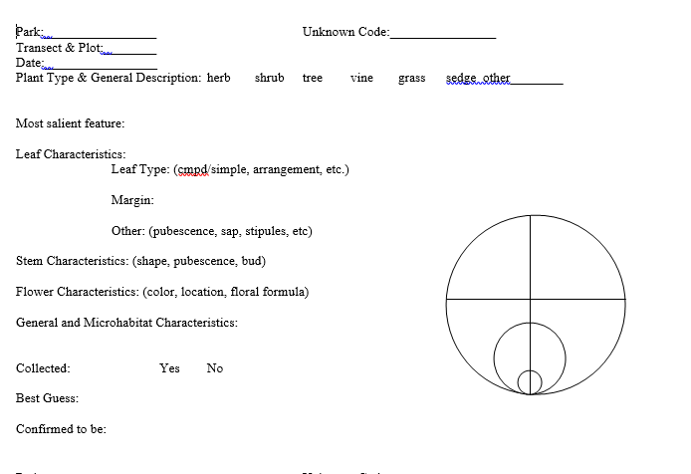

**Figure 8.0.** Unknown plant form. Two forms can be fit to one sheet of paper for copying.

Unknown datasheet with examples

Park**:** A four letter alpha code unique to a particular park (example: WICR – Wilson’s Creek National Battlefield, Missouri)

Transect and Plot**:** Vegetation monitoring site, transect and plot number (example: VegMon 5 _20B – monitoring site 5, transect B, plot 20)

Date**:** Include month (mm) / day (dd) / year (yy)

Unknown Code: A unique code using <park code> <unknown number> <date>, e.g., WICRunk2_7_03

Plant type and General Description**:** Circle the appropriate category and provide a detailed description of the overall appearance

Most Salient Feature**:** The feature that identifies this plant from all others; a unique characteristic

Leaf Characteristics**:** Describe the leaf type, leaf margin, leaf surface, petiole, etc.

Stem Characteristics**:** Describe the shape, pubescence, markings and color of the stem, as well as the bud characteristics.

Flower Characteristics**:** Describe the floral formula, location (axillary or terminal), habit (indeterminate or determinate), pubescence and color.

General and Microhabitat Characteristics**:** List other species located in the general vicinity, selecting the more conservative species in the area. Describe the microhabitat in which it was found.

Collected**:** Circle yes or no, whether a specimen was collected.

Best Guess**:** Preliminary guess about species in field.

Confirmed to be**:** After consultation of reference books and/or herbarium, the species determined.